**Yard Sale!**

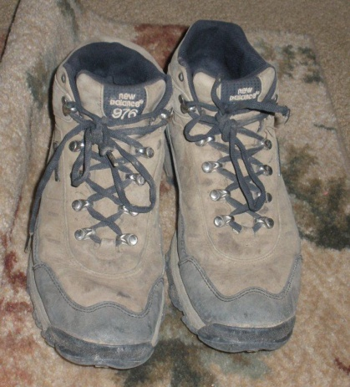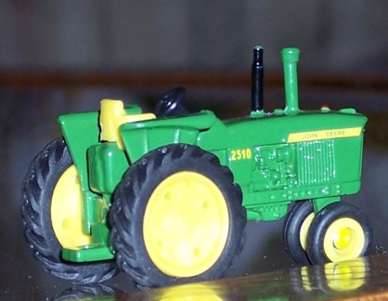

**Hundreds of items for sale.** After 20 years, we are moving to a smaller house and are selling anything that won’t fit. Everything for sale must go!

* When: ***August 7, 8, 9*** from ***9:00 a.m. to 7:00 p.m.***
* Where: ***139 Ravel Boulevard***
* What: something for everyone – from clothing to collectibles

Questions? Call 555-9820.